**Types of Sampling Techniques**

Sampling is widely used by researchers in [market research](https://www.questionpro.com/blog/what-is-market-research/) so that they do not need to research the entire population to collect actionable insights. It is also a time-convenient and a cost-effective method and hence forms the basis of any [research design](https://www.questionpro.com/blog/research-design/).

Example, if a drug company wants to research the impact of particular drug on population of a country, researcher will take sample of people from each demographic and then conduct the research which will give them a indicative feedback of impact of drug on the population.

Population is the collection of the elements which has some or the other characteristic in common. Number of elements in the population is the size of the population.

Sample is the subset of the population. The process of selecting a sample is known as sampling. Number of elements in the sample is the sample size.

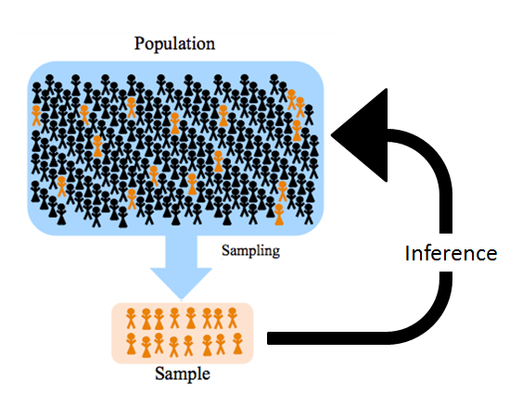

[Sampling](https://www.questionpro.com/audience/) is defined as the process of selecting certain members or a subset of the population to make statistical inferences from them and to estimate characteristics of the whole population.

**Types of Sampling methods**

* Probability Sampling
* Non-Probability Sampling

**Probability Sampling**

This Sampling technique uses randomization to make sure that every element of the population gets an equal chance to be part of the selected sample. It’s alternatively known as random sampling.

**Non-Probability Sampling**

It does not rely on randomization. This technique is more reliant on the researcher’s ability to select elements for a sample. Outcome of sampling might be biased and makes difficult for all the elements of population to be part of the sample equally. This type of sampling is also known as non-random sampling.

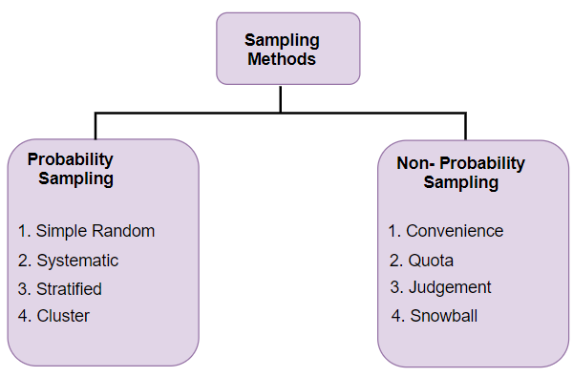

**Simple Random Sampling:** Each individual is chosen entirely by chance and every member has an equal chance of getting selected to be the part sample. It is used when we don’t have any kind of prior information about the target population.

Advantage: the most straightforward method of probability sampling

Disadvantage:  you may not select enough individuals with your characteristic of interest, especially if that characteristic is uncommon.

Example: Selecting 10 people from population of 50 people. Each people has equal chance of getting selected. Probability of selection is 1/50.

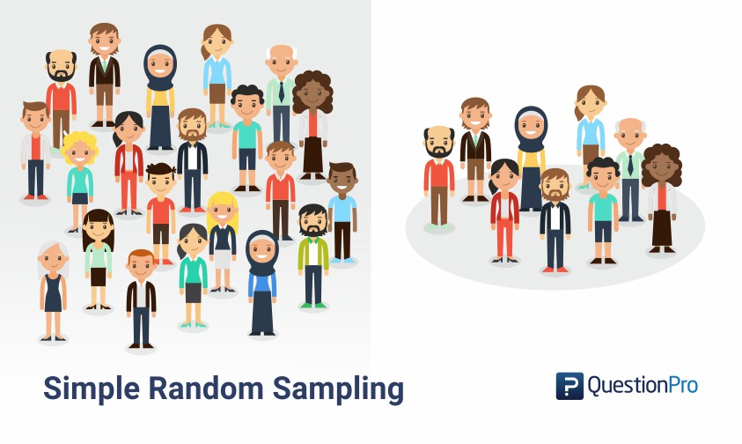

**Systematic Sampling:**

In [systematic sampling method](https://www.questionpro.com/blog/systematic-sampling/), elements of a sample are chosen at regular intervals of a population. It requires selection of a starting point for the sample and sample size that can be repeated at regular intervals.

For example, a researcher intends to collect a systematic sample of 500 people in a population of 5000. Each element of the population will be numbered from 1-5000 and every 10th individual will be chosen to be a part of the sample (Total population/ Sample Size = 5000/500 = 10).

Advantages: More convenient and least time consuming

Disadvantage: Sample can be biased

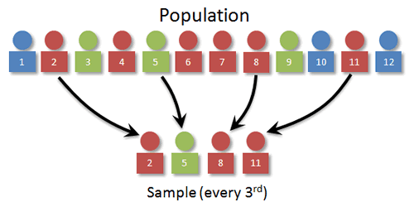

**Stratified Sampling**

This technique divides the members of the population into small subgroups (strata) based on the similarity in such a way that the members within the group are homogeneous and heterogeneous among the other subgroups formed. And then the members are randomly selected from each of these strata. We need to have prior information about the population to create subgroups.

Advantage: Improves accuracy and reduces sampling bias

Disadvantage: It requires knowledge of the appropriate characteristics of the sample frame and it can be difficult to decide which characteristics to stratify by.

Example:

For example, in a study of the health outcomes of nursing staff in a county, if there are three hospitals each with different numbers of nursing staff (hospital A has 500 nurses, hospital B has 1000 and hospital C has 2000), then it would be appropriate to choose the sample numbers from each hospital *proportionally* (e.g. 10 from hospital A, 20 from hospital B and 40 from hospital C).

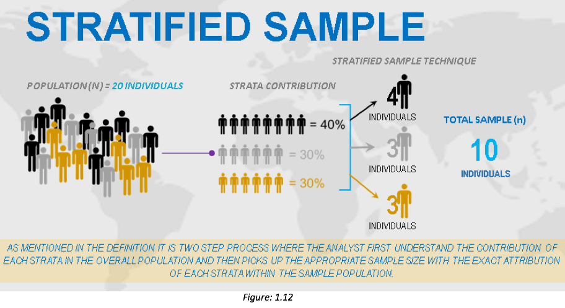

**Clustered Sampling**

In clustered sampling, subgroups of the population are used as the sampling unit, rather than individuals. The population is divided into subgroups, known as clusters, which are randomly selected to be included in the study. Clusters are usually already defined, for example individual GP (General practice in UK, Primary care in US) practices or towns could be identified as clusters.

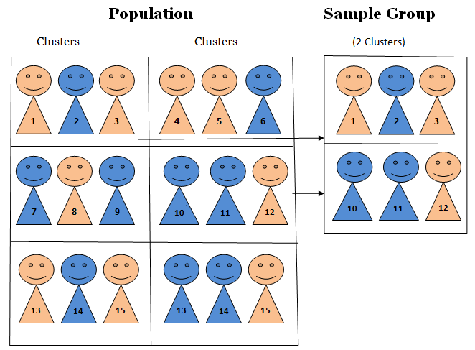

**Single Stage Cluster Sampling**

Entire cluster is selected randomly for sampling.

**Two Stage Cluster Sampling**

Here first we randomly select clusters and then from those selected clusters we randomly select elements for sampling

Advantage: Cluster sampling can be more efficient that simple random sampling, especially where a study takes place over a wide geographical region.

Disadvantage: Increased risk of bias, if the chosen clusters are not representative of the population, resulting in an increased sampling error.

**Multi-Stage Sampling**

It is the combination of one or more methods described above.

Population is divided into multiple clusters and then these clusters are further divided and grouped into various sub groups (strata) based on similarity. One or more clusters can be randomly selected from each stratum. This process continues until the cluster can’t be divided anymore.

For example, country can be divided into states, cities, urban and rural and all the areas with similar characteristics can be merged together to form a strata.

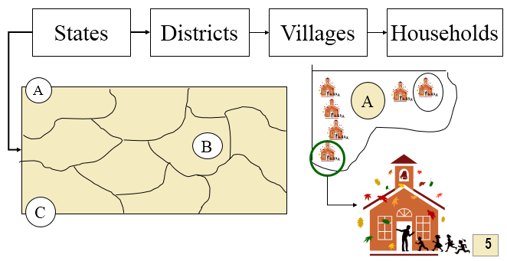

**Non probability Sampling Methods**

**Convenience sampling**

Convenience sampling is perhaps the easiest method of sampling, because participants are selected based on availability and willingness to take part. This method is used when the availability of sample is rare and also costly. So based on the convenience samples are selected.

For example, startups and NGOs usually conduct convenience sampling at a mall to distribute leaflets of upcoming events or promotion of a cause – they do that by standing at the entrance of the mall and giving out pamphlets randomly.

Advantage: Easiest sampling method

Disadvantage: Results prone to significant bias because those who volunteer to take part may be different from those choose not to and sample may not be representative of population.

**Quota Sampling**

This type of sampling depends of some pre-set standard. It selects the representative sample from the population. This method of sampling is often used by market researchers. Interviewers are given a quota of subjects of a specified type to attempt to recruit.

For example, if population has 60% male and 40% female then our sample should reflect same percentage of male and female.

Advantage: Sample will have same attributes that are found in population

Disadvantage: Sample may not be representative of all characteristics of population due to non-random nature of sampling

**Judgement (or Purposive) Sampling**

Also known as deliberate, selective, or subjective, sampling, this technique relies on the judgement of the researcher when choosing who to ask to participate. Only those elements will be selected from the population which suits the best for the purpose of our study.

For instance, when researchers want to understand the thought process of people who are interested in studying for their master’s degree. The selection criteria will be: “Are you interested in studying for Masters in …?” and those who respond with a “No” will be excluded from the sample.

Advantages: Time and cost effective

Disadvantage: prone to errors of judgement by the researcher

**Referral /Snowball Sampling**

This technique is used in the situations where the population is completely unknown and rare. Existing subjects are asked to nominate further subjects known to them, so the sample increases in size like a rolling snowball.

This sampling method is implemented in situations where the topic is highly sensitive and not openly discussed such as conducting surveys to gather information about HIV Aids.

Advantages: effective when sample is difficult to identify

Disadvantage: risk of selection bias

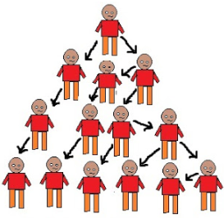

**Use of Probability Sampling**

* Reduces sample bias
* Used for Diverse population
* Create an accurate sample

**Use of Non-Probability Sampling**

* Create a hypothesis (when no prior info is available)
* Exploratory research
* Budget and time constraints